**Setting up GenAMap**

You can download the GenAMap software from this webpage: <http://cogito-b.ml.cmu.edu/genamap/join.html>

Please click on the following link:

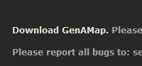

The download consists of a ZIP file. Unzip this file. The executable is GenAMap3.1/GenAMap3.1/dist_sav/GenAMapMain.jar

To run this file, you need to have Java installed. If you do not have Java installed, please download it from here: <http://java.com/en/download/index.jsp>

Once Java is installed, you can run the executable either by double-clicking it (if you Java is set up that way) or from the command line by typing “$(JAVAPATH) -jar GenAMapMain.jar” (do not type the quotes ...)

Here, “$(JAVAPATH)” either stands for the location of your java executable (e.g. in Windows: C:\Program Files (x86)\Java\jre7\bin\java.exe) or just “java”.

When GenAMap starts, you should see a login screen like so:

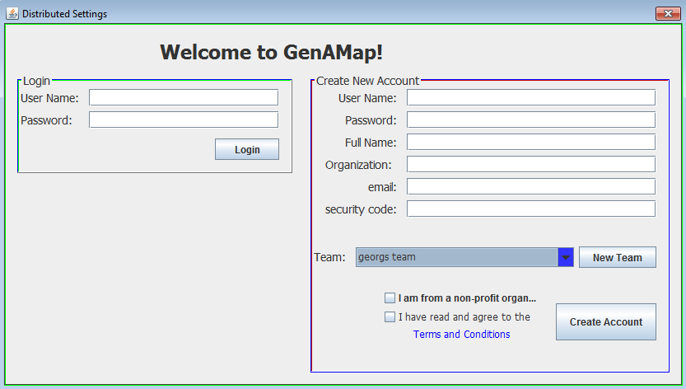

GenAMap user accounts are organized by teams. A team is a meta-account that contains multiple user accounts who all share access to the same data. As a new user, you must associate yourself with a team. Do this by either creating a new team or joining a team that one of your collaborators has created.

Note: anything that happens after this point will only work when you are connected to the internet.

To create a new time, please click on “New Team”. You will be asked to enter a security code. Please enter X76;;PP!@zxiw

Then, choose a name and passcode for your team. Please remember this name and passcode. It will be needed later.

Once you have a team to associate yourself to (either because you just created one or you or your collaborators have created one earlier), it is time to create a user account. Please fill out all the contents of the form on the right hand side and tick the two boxes below. Also, choose your team from the dropdown menu. In the field “security code”, please enter TX12IUM-5PPQ.

Then, click on create account. You need to provide the passcode for the team (which was assigned when the team was created) as well as choose a name and passcode for your user account.

Finally, once the user account is created, log in on the left hand side. This completes the set-up process. You should now see the GenAMap main screen like so:

